1. **Respecting Personal Space** 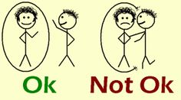

Some kids are close talkers. Others crawl into the laps of acquaintances without any idea that the other individual feels uncomfortable. It’s important to teach kids how to respect other people’s personal space.

Create household rules that encourage kids to respect other people’s personal space. “Knock on closed doors,” and “Keep your hands to yourself,” are just a few examples.

If your child grabs things out of people’s hands or pushes when impatient, establish consequences. If your child climbs into the laps of acquaintances or stands too close to people while talking, use it as a teachable moment. Take your child aside and provide some coaching about personal space issues.

**How to Practice**

Teach your children to stand about an arm's length away from people when they're talking. When they're standing in line, talk about how close to be to the person in front of them and talk about keeping their hands to themselves. You might role-play various scenarios to help them practice describing appropriate personal space.

1. **Making Eye Contact** 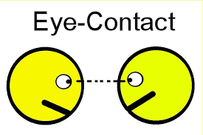

Good eye contact is an important part of communication. Some kids struggle to look at the person they’re speaking to. Whether your child is shy and prefers to stare at the floor or simply won’t look up when engrossed in another activity, emphasize the importance of good eye contact.

If your child struggles with eye contact, offer quick reminders after the fact. In a gentle voice, ask, “Where should your eyes go when someone is talking to you?” You don't want to cause a shy child additional anxiety. And provide praise when your child remembers to look at people when they’re talking.

**How to Practice**

You might even show your children how it feels to hold a conversation with someone who isn’t making eye contact. Ask them to share a story while you stare at the ground, close your eyes, or look everywhere except for at them. Then, invite them to tell another story and make appropriate eye contact while they're talking. Afterward, discuss how it felt in each scenario.

1. **Using Manners** 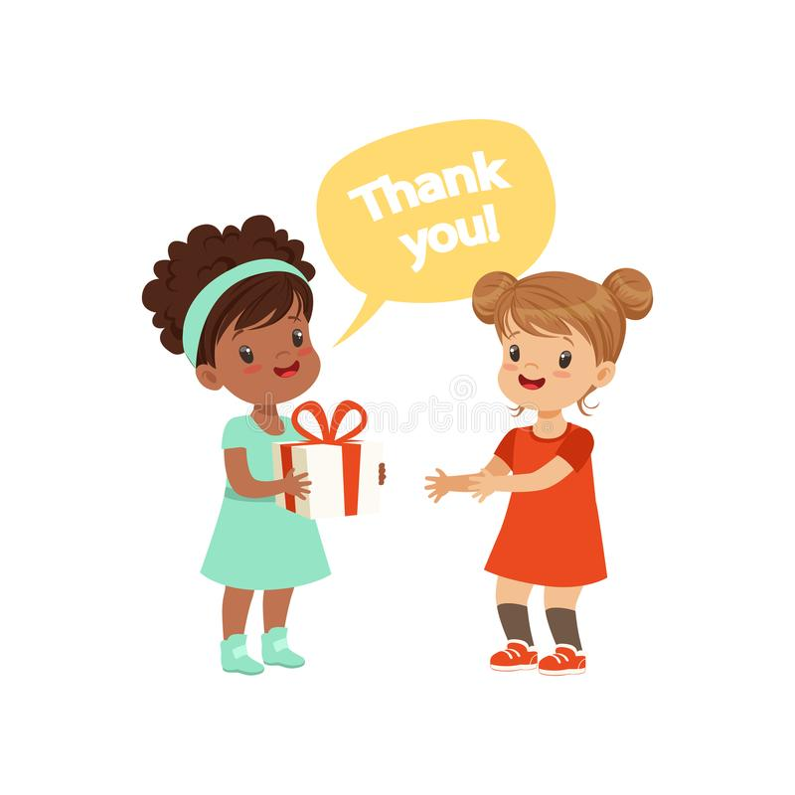

Saying please and thank you and using good table manners can go a long way toward helping your child gain attention for the right reasons. Teachers, other parents, and other kids will respect a well-mannered child.

Of course, [teaching manners](https://www.verywellfamily.com/ways-to-teach-kids-old-fashioned-manners-in-todays-world-1094897) can feel like an uphill battle sometimes. From burping loudly at the table to acting ungratefully, all kids will let their manners go out the window sometimes.

It is important, however, for kids to know how to be polite and respectful—especially when they’re in other people’s homes or at school.

**How to Practice**

Be a good role model with your manners. That means saying, “No, thank you,” and “Yes, please,” to your child on a regular basis. And make sure to use your manners when you’re interacting with other people. Offer reminders when your children forget to use manners and praise them when you catch them being polite.

Source: <https://www.verywellfamily.com/seven-social-skills-for-kids-4589865>